Task 12 — Docker Image and Container Lifecycle
Step 1 — Check whether Docker is running
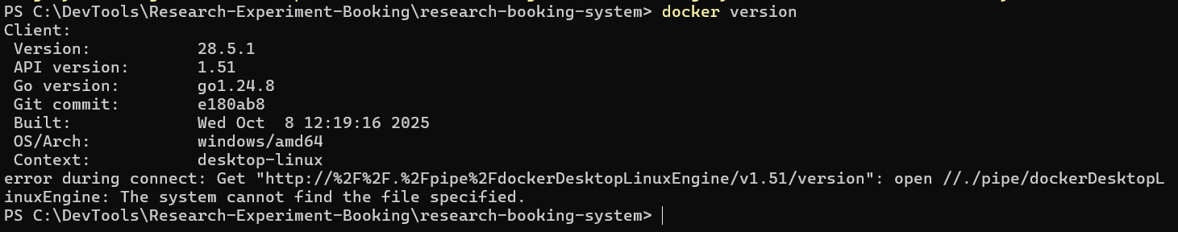
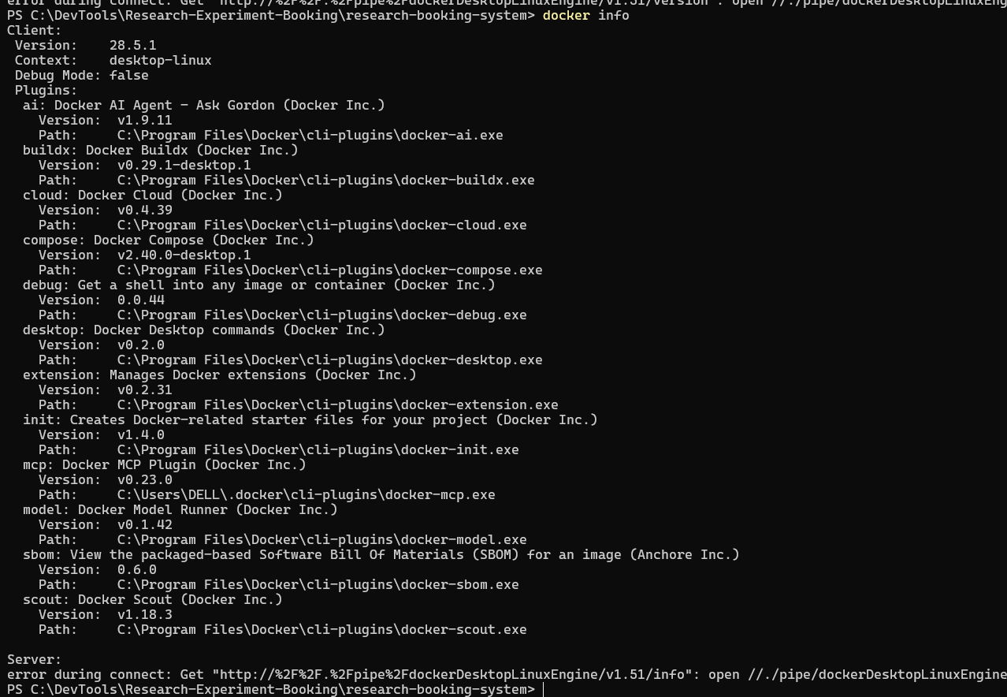

0. Start the command log and check Docker

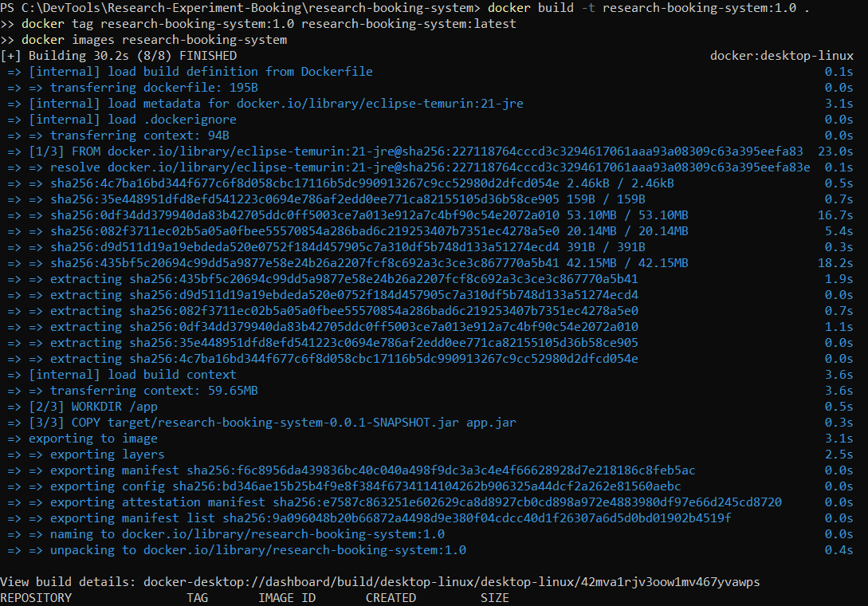
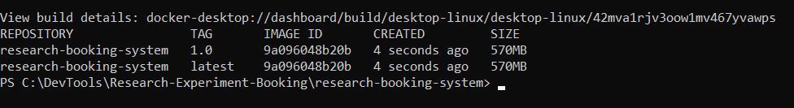
01-dockerfile.png
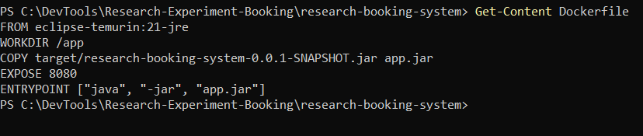
02-build-and-tag.png
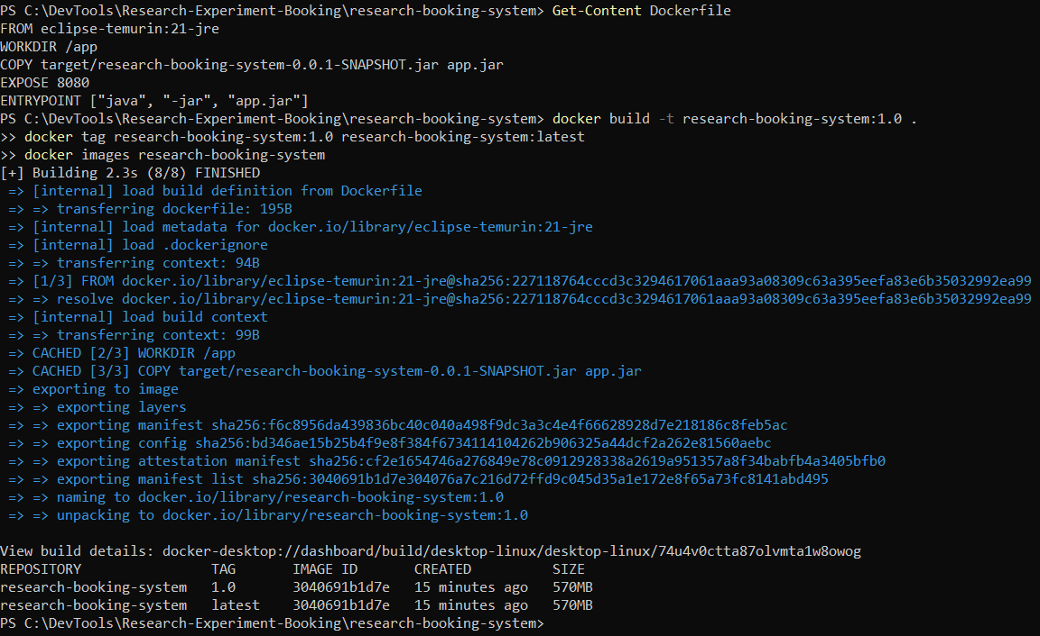
03-image-details.png
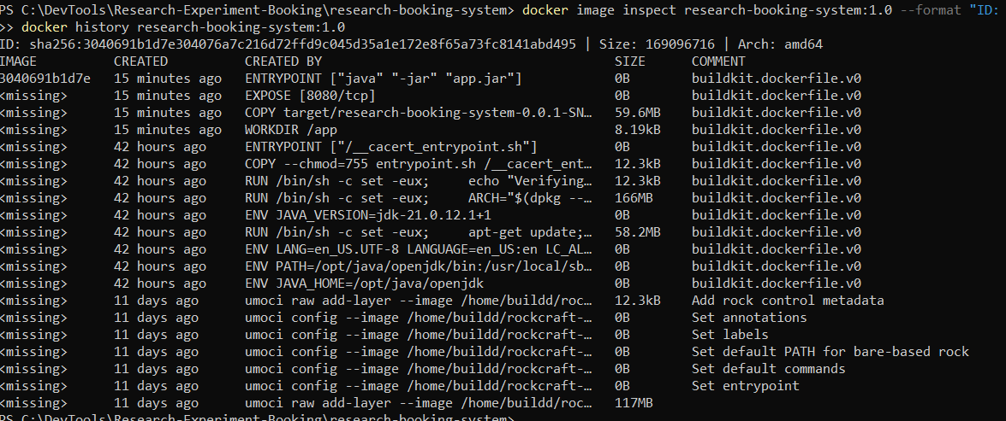
04-container-running-ports.png
05-container-logs.png
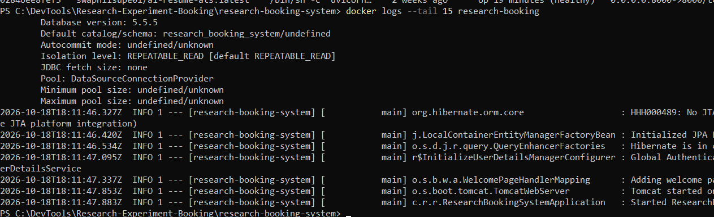
06-api-test.png
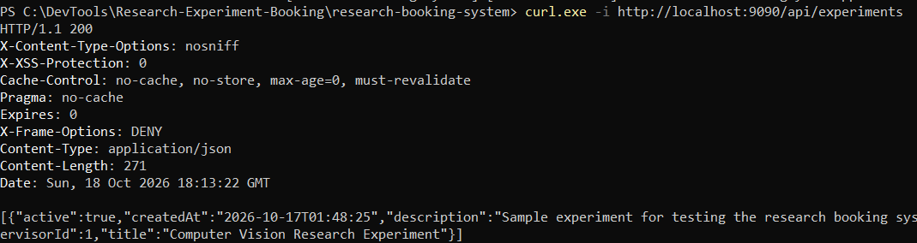
07-browser-ui.png**: open
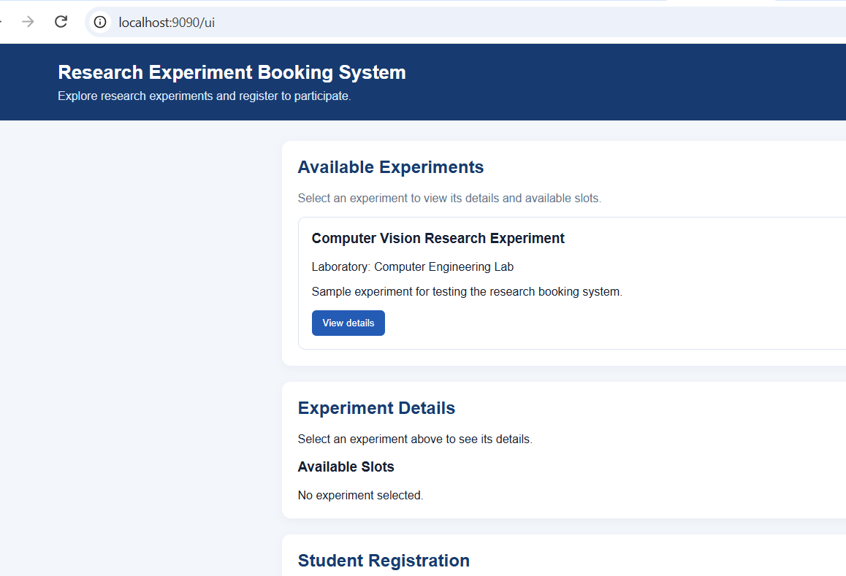
08-stats-top.png
10-stop-start-restart.png
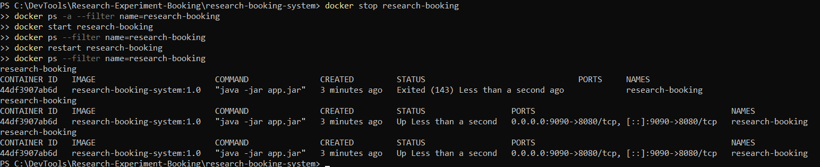
11-remove.png
